Glowtag FD-07 — Bots

What the lobby gives us
Matchmaking & Lobby System v0.4 fills empty slots with bots and supplies only the count — its Bot Fill section states that "AI and difficulty: per-game, out of scope here." That is this document.
From the lobby | Value
Count | MaxPlayers − real players, fixed at StartMatch, never changed after
Ownership | Simulated by the authority. No Fusion PlayerRef, no input bandwidth
Start positions | Occupy start anchors exactly as players do
Appearance | A robot from the roster, indistinguishable in-match, labelled in lobby and results UI
Mid-match disconnect | A dropped player is not replaced by a bot

The consequence that matters: every Glowtag match now has exactly six participants. Bots fill any slot a player did not, so the partial-field cases the earlier documents planned around no longer occur.

The design rule
A bot is an input source, not a second movement system. Each tick the authority synthesises a NetworkInput for every bot and feeds it through the same Layer A to Layer B pipeline a player's input goes through.
Everything useful follows from that one decision. Bots inherit driving, contact, spin-out and recovery for free. They can never do something a player could not. And when the drive model is retuned, bots retune with it — there is no second movement implementation to keep in sync.

Behaviour
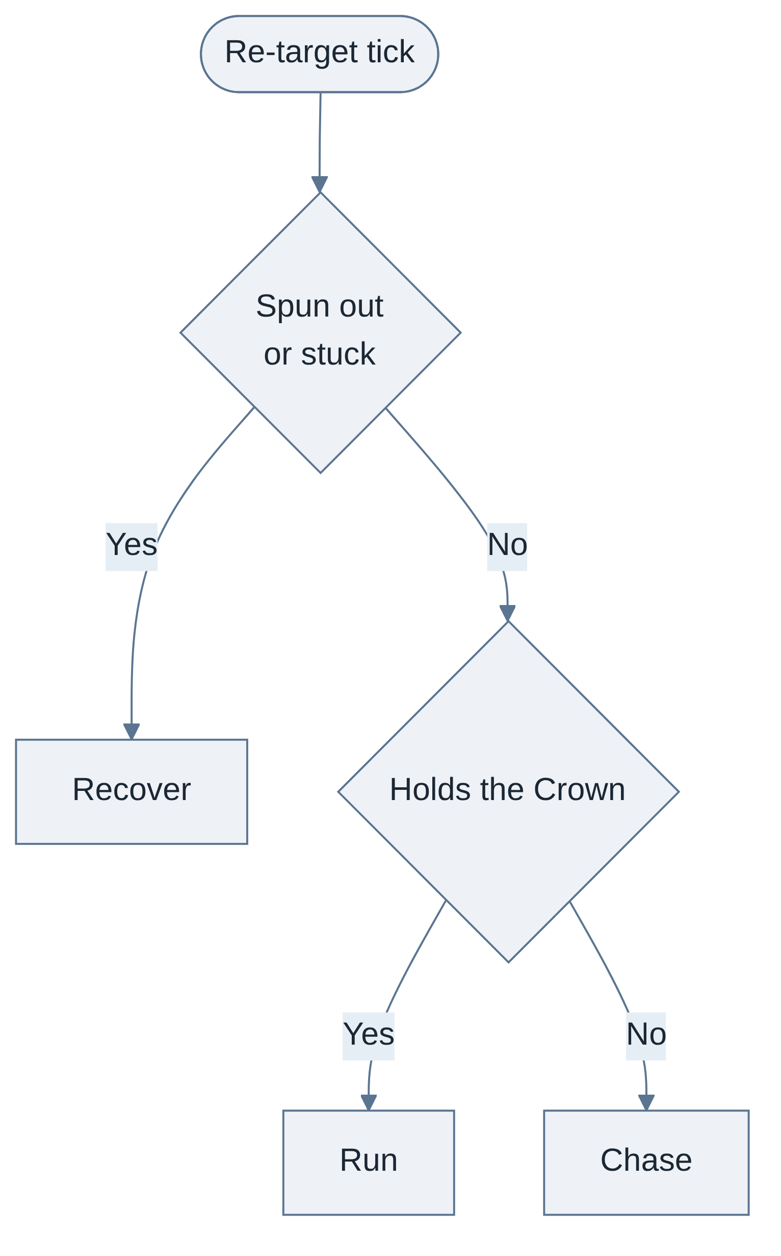
State | Entered when | Target
Chase | Default | The Crown, or whoever is holding it
Run | This bot holds the Crown | Directly away from the nearest rival
Recover | Spun out, or below stuck_speed for bot_stuck_ticks | The arena centre

That is the entire decision layer. There is no planning, no prediction of where the holder is going, and no coordination between bots.

Driving
Input | Rule
Throttle | Always held
Brake | Never used
Steer | Angle to target divided by bot_steer_full_angle, clamped to −1..1
Avoidance | Three short rays — forward, forward-left, forward-right. A hit steers away from it and overrides the target for that tick
Hop, drift, boost | Never used

Bots do not drift. They never charge a reserve, never hit a release window, never chain, and so never land a boosted hit at boost_bump_multiplier 1.6×. This is the intended skill floor rather than an omission: the gap between a bot and a player who drifts well is exactly the gap the drift economy exists to create.
Why a bot this simple is viable at all. Stealing fires on any contact, per FD-03. A bot that only knows how to drive at the holder will therefore take the Crown regularly. Under a slam-only rule it would almost never steal, because a slam needs a near-perpendicular approach at speed — which is precisely what this bot cannot set up. The two decisions are linked: if FD-03's open decision 1 tightens the steal rule after playtest, bots get materially weaker and this document needs revisiting in the same pass.

Power-ups
Rule | Detail
Crates | Driven over, never detoured to. A bot takes one only when it is already within bot_crate_angle of its heading
Activation | Immediately on pickup, always. No holding, no timing, no choosing a moment
Which items | All five. Whatever it rolls, it fires

Firing blind means a bot sometimes wastes an item — a Damper Field while not holding the Crown, a Grapple Field while holding it. That waste is accepted: it costs nothing to implement and makes bots slightly weaker, which is the right direction. If they look foolish in playtest, two conditions fix it (skip Damper when not holding, skip Grapple when holding) and nothing else changes.

Difficulty
Two dials, both fixed per bot for the whole match.
Dial | Effect
bot_reaction_ticks | How often the bot re-evaluates its target. Higher is slower to react and easier to escape
bot_aim_error | A constant angular offset on the steer target. Higher wanders more

No difficulty tiers in v0.1. Every bot uses the same two values. If a mixed field is wanted later, vary these two per bot and change nothing else.

Determinism and identity
Bots have no PlayerRef. Glowtag therefore addresses every participant by a `ParticipantRef` — the PlayerRef for a real player, a stable slot index for a bot. Everywhere the other Glowtag documents order or seed by PlayerRef — contact tie-breaks in FD-03, spawn selection in FD-02, item rolls in FD-04 — they mean ParticipantRef.
Bot input is computed on the authority from replicated state and the tick, so a re-simulation reproduces it exactly. bot_aim_error is a fixed constant, not a per-tick draw; anything that does vary is seeded from tick and ParticipantRef, per the foundation's no-unseeded-randomness rule.

UI
Where | Treatment
Lobby | Labelled as a bot, per the lobby document
In-match scoreboard | No bot marker. The lobby specifies bots are indistinguishable in-match. They appear under their roster robot's name
Standings screen | Labelled as bots
Superlatives | Bots are eligible. A bot taking "most distance driven" is fine, and mildly funny

A player who loses to a bot only finds out on the standings screen. That is the lobby's ruling rather than a choice made here, and it is recorded so it reads as deliberate.

Tuning
Parameter | Provisional | Range
bot_reaction_ticks | 12 (~0.2 s) | 4 to 30
bot_aim_error | 3 deg | 0 to 10
bot_steer_full_angle | 45 deg | 25 to 70
bot_whisker_length | ~1.5 chassis lengths | —
bot_crate_angle | 25 deg | 10 to 45
bot_stuck_ticks | 90 (~1.5 s) | 45 to 180

Edge cases
Case | Handling
A bot holds the Crown at the buzzer | Nothing special. A bot can win the round
A bot is spun out while holding | Keeps the Crown and enters Recover. Identical to a player
Two bots converge on the same target | Allowed. Bots never coordinate
The last real player disconnects | Round ends. A field of bots alone is not a match — see FD-01
A player disconnects mid-match | Not replaced. Glowtag does not take the lobby's per-game override; a field that shrinks for the rest of a 90-second round is not worth the code
A bot is pinned against a wall by a player | Legitimate. Recover state and the foundation's min_exit_speed get it out eventually

Open decisions
- Field size. Bots guarantee a full field, so MaxPartySize now fixes the participant count for every match rather than capping it. Six was chosen when partial fields were possible — six robots in an arena crossable in four to six seconds may be too busy, and four is the lobby's own provisional default. Worth re-ruling before the arena blockout.
- Difficulty tiers. None in v0.1. Revisit only if playtesters find bots uniformly too easy or too hard.
- Bot strength depends on FD-03's steal rule. Revisit together, not separately.

